

STANDARD OPERATING PROCEDURE

Blastocyst Vitrification - Vitrolife

PRINTED COPIES OF THIS DOCUMENT ARE UNCONTROLLED
PLEASE REFER TO Q PULSE FOR THE LATEST VERSION

DOCUMENT DETAILS
AUTHOR (NAME & JOB ROLE): |  |  | Lyndsey Zujovic, Group Director of Embryology
DOCUMENT APPLICABLE TO: |  |  | TFP GROUP (ALL)
DISTRIBUTION GROUP: |  |  | All Laboratory Staff
AMMENDMENT HISTORY
REVISION | ACTIVE DATE | CHANGES MADE
1.0 | 28/01/2020 | Initial release.
2.0 | 10/05/2020 | Oil overlay added (excluding Vitri 3)
3.0  4.0  5.0 | 20/05/2021  02/10/2021  29/07/2022 | Additional details added about how to collapse blastocysts. Additional witnessing checks added for split cycles.  Witnessing checks updated to include the use of three identifiers  Direct cleavage/reverse cleavage embryos that form blasts A-C can be vitrified. Pipette range adjusted to include a 200-310µl pipette for use in Vitri 1 and Vitri2

Purpose
To describe the procedure for vitrifying blastocysts using the Rapid I device with Vitrolife vitrification kits. Blastocyst cryopreservation can be used to preserve fertility or store blastocysts following treatment. Excess blastocysts can be stored following embryo transfer or a ‘freeze all’ strategy may be adopted for medical reasons.

Scope
Applicable to all Embryologists and practitioners trained to carry out vitrification of blastocysts:
Gamete/embryo donation and surrogacy are prohibited in Kuwait, as such any references to this are not applicable to clinics in Kuwait.

Definitions
PPE Personal Protective Equipment

Responsibilities
            - General Manager
The General Manager (GM) is accountable for the implementation of this clinic-wide process.
            - Laboratory Manager (Clinic)
The Laboratory Lead is responsible for ensuring that current practice is in line with this SOP, all staff have been trained appropriately and signed off as competent to enable them to work safely and ensure patient’s safety at all times. The Laboratory Lead is also responsible for ensuring that all non-compliance with this SOP or incidents occurring are properly investigated and any corrective action taken. They are also responsible for auditing compliance to this SOP.

            - Quality Manager
The Quality Manager is responsible for ensuring that all staff are aware of and comply with the requirements specified in this document. The QM is also responsible for ensuring all non-compliance with this SOP, or incidents occurring are properly investigated and any corrective action taken is recorded on QPulse.

            - All Staff
All staff are responsible for following the process laid out in this document, ensure they receive up-to-date training to enable safe working and to request further training if they feel it is required. Staff are also responsible for reporting any non-compliance or incidents occurring on QPulse and following up the outcome of any reported incidents/non-conformities.

Procedure

5.1 Equipment & Consumables required
Equipment/Consumables Required
- Serological pipettes
- Rapid I devices
- Heat sealer
- Rapid I Liquid Nitrogen Box
- Liquid Nitrogen
- Pre pulled Pipettes (200-310µm and 155-200µm)
- Timers
- Pipette and tips
- Cane/Cryocassette/visi
- Clinical waste bin

Dishes/Media Required
- 5 well dishes
- 40mm Collapsing Dish (optional)
- ICSI dishes
- Rapid Vit Blast Media
- Oil
- RI Witness Tags
- Bar Code Labels (optional)

5.2 Equipment Checks
Prior to the vitrification procedure the equipment to be used must be checked to ensure it is operating optimally.
The flowhood must be checked to ensure the flow is on and the hood is clear of used dishes/pipettes and tubes.
Ensure the RI heated stage is switched on and at the correct set point. Vitrification is performed at 37◦C.
Fill the Rapid I Cryobox and a dilvac with liquid nitrogen. Ensure appropriate PPE is used when handling liquid nitrogen.
Ensure the heat sealer is present and switched on.

5.3 Witnessing Checks (Full Name, Clinic Number and D.O.B)
Before beginning the Vitrification process check the laboratory notes to ensure that blastocyst vitrification is indicated.
Check the required HFEA forms (or country specific equivalent) have been completed providing consent to embryo freezing.
Blastocyst vitrification requires a second witness to be used alongside RI witness.
Check the patient’s full name, clinic number and D.O.B. on the GTL culture dish matches the vitrification dish, laboratory notes and RI witness system. In addition, check the patient’s full name, clinic number, D.O.B. and date of vitrification on the Rapid I straws and visi/cassette match that on the laboratory notes and RI witness system. Each straw must be labelled with the number of blastocysts and the grade of the blastocyst/well number. Approve these checks on the RI witness system and both operator and witness must sign for these checks.
Where split cycles have taken place, for example donor:partner sperm split, IVF:ICSI split or frozen oocytes:fresh oocytes, these blastocysts must be kept separate and the Rapid I straws labelled to allow for clear traceability. Blastocysts being vitrified following PGT must also be clearly labelled with the corresponding ‘embryo number’.

5.4 Preparation of Dishes
Prepare the Blastocyst collapsing & Vitrification dishes 30-60 minutes prior to use (validate time period required locally) and warm in an ungassed incubator.
Gently invert the Rapid Vit Blast solutions 3 times prior to making the dish. Place 0.5ml of Vitri1, 0.5ml of Vitri2 and 0.5ml of Vitri3 in separate wells of a 5 well dish. Overlay Vitri1 and 2 with 0.3ml of oil. Prepare one Vitrification dish per 4 Rapid I’s to be used.
If there are differing grades of blastocysts to be frozen it may be useful to create two wells with Vtri1 solution so that higher and lower quality blastocysts are kept separate.

Vitri1 + Oil Vitri2 + Oil

Vitri3

Figure 1: Blastocyst vitrification dish set-up
Optional collapsing dish: prepare one 40mm dish for collapsing blastocysts prior to vitrification. Pipette 5 x 10µl drops of GMOPs⁺ near the centre of the dish using a multi-pipette. Overlay with 4-5mls of oil.
One ICSI dish is also required for every 5 well dish for the loading procedure.

5.5 Timing of Vitrification Procedure & Selection of Blastocysts
Perform blastocyst vitrification on Day 5 or Day 6 of embryo culture.
Blastocysts graded A-C are considered suitable for vitrification.
Blastocysts that have shown a pattern of reverse cleavage or direct cleavage are suitable for freezing/biopsy should they reach a grade A-C. They should however be considered ‘low priority’ for transfer.

5.6 Cryoprotectant Exposure Times
Vitrolife Rapid Vit Blast
Vitri1: Exposure time 5-20 minutes
Vitri2: Exposure time 2 minutes
Vitri3: Exposure time 45 seconds

5.7 Preparation for the Procedure
Label sufficient Rapid I’s for the number of blastocysts to be vitrified. 1-2 blastocysts can be placed on each Rapid I. Different coloured Rapid I’s can be used to denote singles/doubles or blastocysts of different grades.
Identify a location for the samples within the cryostore based on the patient’s infection screen results with negative, positive and unscreened samples being stored separately. Split fertility preservation patient’s samples between a minimum of two dewars.
Enter the storage location(s) in IDEAs. Prepare a storage card if required.

5.8 Collapse the Blastocyst Prior to Vitrification
Blastocysts must be laser or manually collapsed prior to vitrification.
Blastocysts can be collapsed either in their culture dish if there are a small number of blastocysts to vitrify or following transfer into a 40mm GMOPS⁺ culture dish.
Transfer the blastocysts to the heated stage of the inverted microscope. Focus on the outer ring of TE cells closest to the zona pellucida. Identify the position of the ICM. Select a TE cell junction away from the ICM. Fire a single laser shot at the junction to initiate blastocyst collapse. Laser collapse each blastocyst in turn. Check for initiation of collapse, if not observed, a second laser shot may be required.
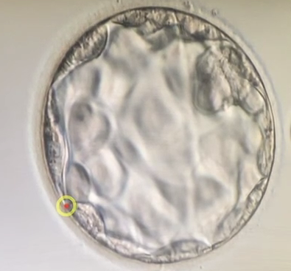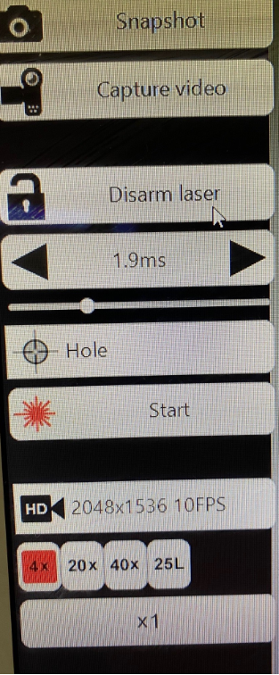
Figure 2: Junction between TE cells where laser shot can be fired and Octax laser settings
Settings for the Octax laser are displayed above along with an image showing a suitable site for the laser shot. One or two laser shots (hole setting) of approximately 1.9ms is usually sufficient to initiate collapse.
Equivalent settings for the Saturn laser are approximately pulse width 0.395ms, hole size 8.5µm.
Immediately proceed to vitrification once the laser collapsing has been completed.

5.9 Vitrification Procedure
Maintenance of a temperature of 37◦C is crucial during blastocyst vitrification. Temperature can be maintained either using a heated stage or an ungassed G85/incubator.
Using a 200-310µm pipette, transfer the number of blastocysts to be placed on up to 4 Rapid I’s into Vitri1. Immediately start the timer for 5 minutes.
Wash the blastocysts within Vitri1, replace the lid on the dish and culture at 37◦C for 5 minutes.
Place the Rapid I’s for this round into the Rapid I cryobox to cool.
After 5 minutes, using the 200-310µm pipette, prime the pipette with solution from Vitri2. Collect the blastocyst to be placed on the first Rapid I and transfer into Vitri2. Immediately start the timer for 2 minutes. Wash the blastocyst in Vitri2.
Blastocysts must remain in Vitri2 for 2 minutes.
With 30 seconds remaining in Vitri2, make 2 x 40µl drops of Vitri3 within the ICSI dish.
Using a 155-200µm pipette, prime the pipette with Vitri3 and transfer the blastocyst into the first drop of Vitri3 in the ICSI dish. Empty the pipette and wash thoroughly through both wash drops.
Remove the metal rod from within the rapid I straw.
Place the blastocyst on the Rapid I. Immediately plunge within the Rapid I straw. The total duration in Vitri3 must not exceed 45 seconds.
Seal the Rapid I straw with the heat sealer.
Repeat for the remaining blastocysts in the Vitri1.
Once all the blastocysts have been vitrified within the dish, repeat the whole process until all the blastocysts have been frozen.
Transfer the vitrified blastocysts to the designated storage location in the nitrogen tank alongside a second witness. Both operator and witness must sign for these checks.
Clear the flowhood of any used consumables. Use Oosafe spray ± sterile water to clean the flowhood.

Standards/Key Performance/Quality Indicators
Blastocyst Survival ≥50% Cells Intact ≥90%

Monitoring

A TFP laboratory manager is responsible for auditing this SOP once annually.
Each laboratory manager is responsible for monitoring each operator’s blastocyst survival rates within their clinic. Any deviation will be discussed at team meetings or supervision meetings
Overall clinic blastocyst survival rates are reviewed every four months at the TFP KPI meeting.

